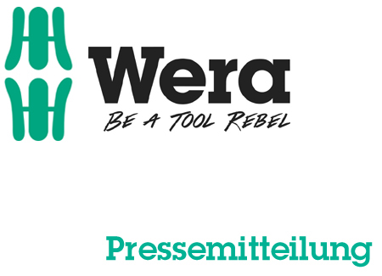

Date: 06 March 2016
Editor: Klaus Teders

The new Wera catalogue in a rebellious outfit:

Be carried away to an emotional world of tools

Over 3,000 tools on more than 500 pages / Slogan: “It’s in our DNA” / Standards challenged time and again / Innovation brochure with special offer prices /

Cologne / Wuppertal. The new Wera catalogue carries the observer away to an emotional world of tools and presents the existing range consisting of over 3,000 assembly tools for screws and nuts. Numerous product novelties with surprising features complete the tried and tested product range.

“It’s in our DNA”
- How does one manage to consistently challenge existing standards and also achieve a result in the process?
- As a tool company, how can rebels be produced and what do they actually look like?
- What part does design play and what part does rock and roll play when it comes to a manufacturer of assembly tools for screws and nuts?
- And last but not least: What product line depth is Wera introducing?
The new Wera catalogue provides answers to all these questions – a publication that perceptibly communicates Wera’s DNA.

Innovations of the tool rebels
Wera has also re-published the innovation brochure in addition to the catalogue. It includes an overview of the current product novelties and other famous products in the Wera range at special offer prices.

The new catalogue and the innovation brochure are available for downloading at www.wera.de and can also be requested there free of charge as a printed version.

More information:

Wera Werk Hermann Werner GmbH & Co. KG

Korzerter Straße 21-25, 42349 Wuppertal / Germany

Phone: +49 (0)2 02 / 40 45 311, Fax: 40 36 34

e-Mail: info@wera.de, Internet: www.wera.de

TECHNO PRESS
Caption:

01_Wera_Catalogue2016
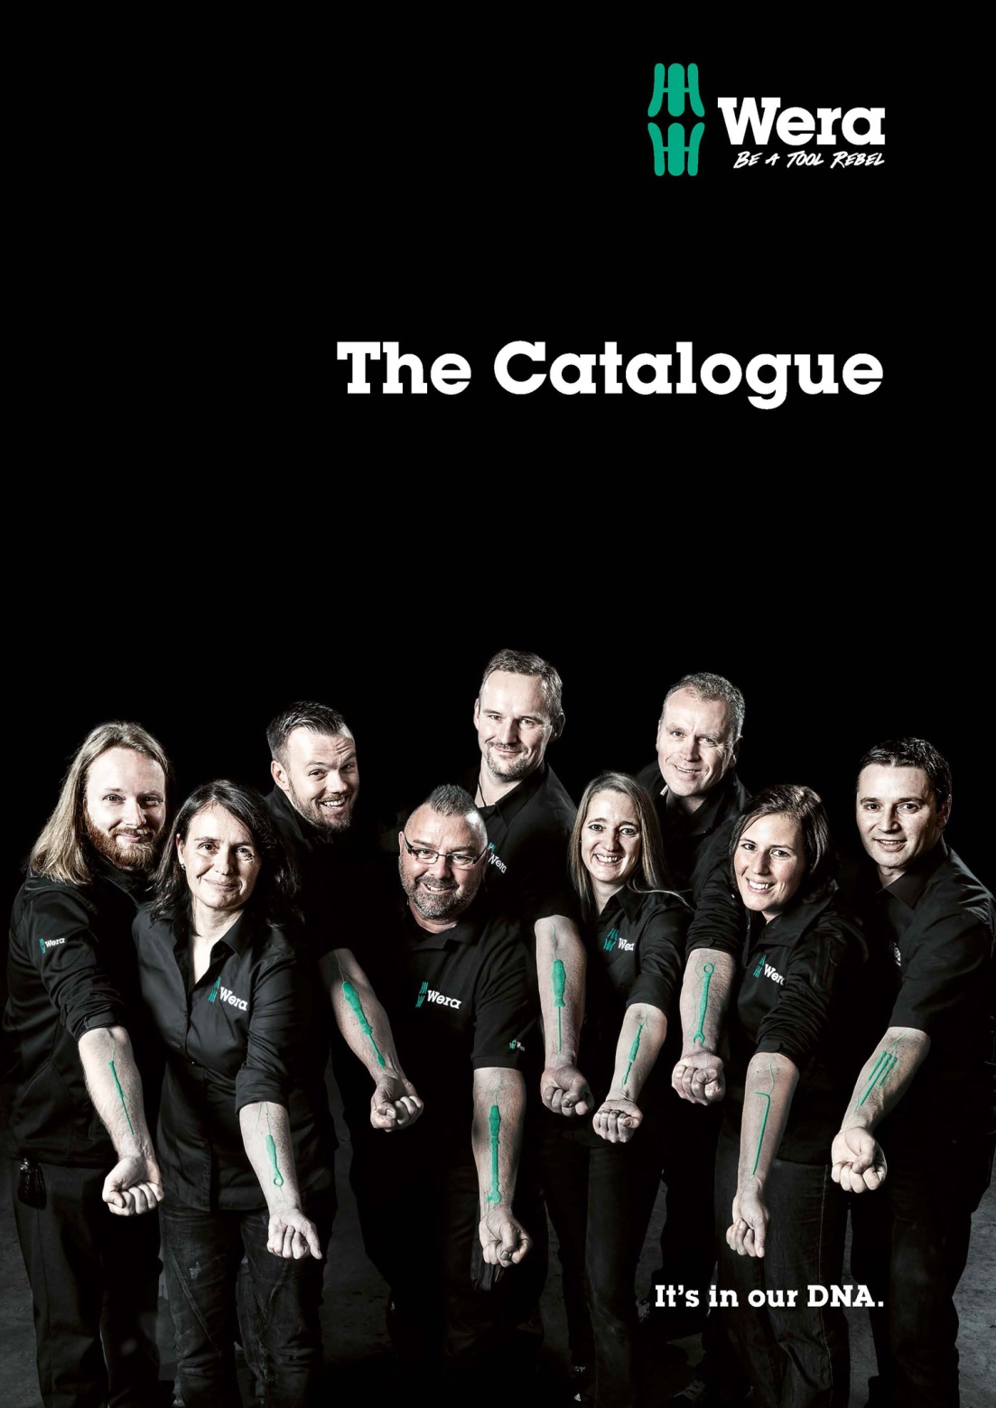
In addition to the current innovations of the manufacturer of assembly tools for screws and nuts, the Wera catalogue contains more than 500 pages showing the existing range consisting of more than 3,000 tools that can be used to solve every conceivable screwdriving job.

Picture: Wera Werk Hermann Werner GmbH & Co. KG

Press contact:

Wera Werk  Hermann Werner GmbH & Co. KG  Detlef Seyfarth  Korzerter Straße 21-25  42349 Wuppertal / Germany  Phone: +49 (0)2 02 / 40 45 311  Fax: +49 (0)2 02 / 40 36 34  e-Mail: info@wera.de | TECHNO PRESS  Presseinformationsdienst  (Press Information Service)  Wolfgang D. Riedel  P. O. Box 10 04 49  42004 Wuppertal / Germany  Phone: +49 (0)2 02 / 9 70 10 0  Fax: +49 (0)2 02 / 9 70 10 50  e-Mail: info@technopress.de
Released for printout, copy requested

